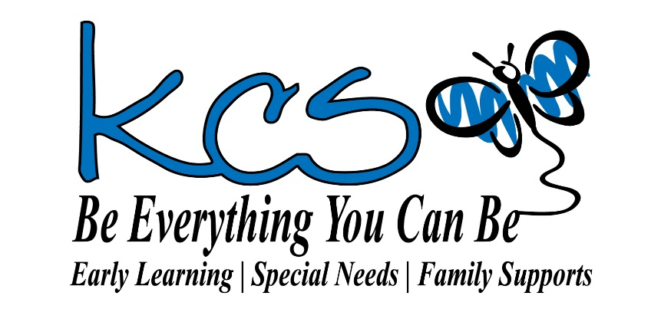

PARENT HANDBOOK
Early Learning and Early Intervention
for Young Children

Toddler
Playschool
Junior Kindergarten (Pre-K)
Outdoor Adventures
Kindergarten
Kids Kamp
Early Intervention
Afterschool

4725 - 43rd Street, Sylvan Lake, AB, T4S 1M3
Ph: (403) 887-5330 Fax: (403) 887-5331 Email: info@kcs78.ca
www.kcs78.ca

CONTENTS

Section:
I Welcome to kcs Association
Team of Professionals
Our Program Directors

II Committed to Quality

III General Things You Need To Know
Yearly Schedule
Class Days and Hours
Arrivals and Departures
Subsidy
Discipline Policy
Provision of Snack
Clothing
Field Trips and Special Events
School Closure
Emergency Evacuation Plan
Notification of Termination/Withdrawal
Suspension/Dismissal
Parent Early Learning Team Communication

IV Programs for Children
Model for Learning
Programs
- Toddler
- Playschool
- Jr. Kindergarten/Pre-Kindergarten
- Outdoor Adventures
- Kindergarten
- Kids Kamp
- Early Intervention
- Afterschool

V Fees

VI Parents as a Part of Our Team

VII Health and Safety

VIII Forms
-Volunteer Agreement
- Policy Statement Agreement

SECTION l

Welcome to kcs Association

TEAM OF PROFESSIONALS

Board of Directors
Allan Bertamini, President

Principal/Executive Director
Trinda DeMont

Office/Finance Administrator
Caroline Johanson

Early Learning Program Director
Elysha Dunlop (School Year 2021-22)

Educators

Early Interventionists

IPP Coordinator

kcs Parents Committee
Parent and Community Volunteers whose efforts
support our Early Learning Centre

PROGRAM SUPPORTS

Typically, throughout the year, we have practicum students from Red Deer College and H.J. Cody School. We also have work experience students from various service agencies in Central Alberta. However, while pandemic restrictions are in place, these activities may be limited. In addition, we are also restricted with volunteers or visitors under the current pandemic conditions.

OUR ORGANIZATION

kcs Association provides a variety of programs and services to children, youth, adults and their families. Serving Sylvan Lake and the surrounding communities since 1978, kcs Association is staffed by a skilled and dedicated team of professionals. Together with parents, volunteers, community members and agencies, kcs Association supports the growth and development of all children, youth and adults.

OUR VISION

A community strengthened through achievements of its members of all abilities.

OUR MISSION

To meet the individual needs of children, youth, adults, and their families through collaborative partnerships, quality supports & services and by maintaining a skilled and dedicated team of professionals.

OUR PHILOSOPHY

We believe in:
- The uniqueness and dignity of each person
- The inclusion of each person with their own gifts & capabilities
- Supporting the person as an individual and the family as a whole
- Fostering connections of each person and their family with resources in the community
- Working with each person, their families and social networks to ensure safety and well-being
- Recognizing and appreciating the efforts of each person, their supporters and staff
- Teamwork and the importance of effective communication
- Fun, laughter & play as the essential ingredients to positive learning & enhanced self- esteem

PROFESSIONAL TEAM

We are committed to maintaining a skilled and dedicated team of professionals. These professionals include:
- certified teachers
- educators trained in child development
- team members trained in rehabilitation
- health care professionals
- various specialists (speech language pathologists, occupational and physical therapists, etc.)

All members of the kcs Team must submit a criminal record check and a vulnerable sector check before commencing employment, as well as, a Child Intervention Check. We also require First Aid/CPR training to meet Licensing requirements. Additional training is undertaken as needed.

Board of Directors

kcs Association is a non-profit society and charitable organization that is run by a volunteer Board of Directors. The Board sets the course of direction for the Association through its policies and procedures and looks after the financial and legal affairs of the Society. The Board meets monthly and takes part in an annual retreat day. The Board facilitates the Annual General Meeting of Society members.

Principal/Executive Director

The Principal/Executive Director oversees and manages the everyday operations of the Association and reports to the Board.

Advisory Committee (LAC) - kcs Parents

The Advisory Committee consists of parents from our different programs. They provide feedback to the Executive Director and the Board. They also volunteer to help with activities like field trips, monthly newsletters, fund-raising etc. During pandemic conditions, the role of the Advisory committee may be limited due to AHS regulations.

Office/Finance Administrator

The Office Administrator coordinates all administrative responsibilities and is also the liaison with the parents for such activities as registration, payments and general information. The financial records and internal financial activities are managed by this person. However, the financial statements for the Board are prepared by an independent party.

Program Directors

The Early Learning/Early Intervention Program Director is responsible for setting and monitoring the curriculum, evaluating individual progress, and supporting the team of Educators. The Family Supports Director manages supports to families in this program. The Adult Services Program has two Directors, Operations and Governance. Together they deliver quality services to the adults in this program. The Leadership team works together with the Principal/Executive Director to coordinate the Associations activities. They meet once a month to review all programs and services to ensure that they are working to meet and support and developmental needs of individuals.

SECTION ll

COMMITTED TO QUALITY

kcs Association strives to ensure quality programs and services for children, youth, adults and families through continuous Team development and monitoring quality programs.

STAFF DEVELOPMENT

As the ongoing training and development of the kcs Team is essential in providing exemplary programs and services, we are closed approximately one day per month for professional development. These days may be used for team development, planning and training. The Team members attend conferences and workshops periodically throughout the year.

ASSURING QUALITY PROGRAMS

Educator Growth and Development

We support and encourage educators pursuing continuous training and development. This policy contributes to the continued excellence of our programs and services.

Annual Evaluations

Annual evaluations are completed for:
- kcs Association programs, organization etc. by parents and team members
- Principal/Executive Director by Board and representatives from the kcs Team and our families
- Program Directors by Principal/Executive Director
- Program Team members by our stakeholders, peers and supervisors

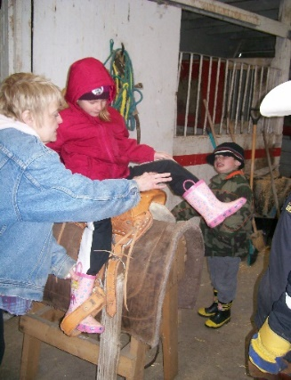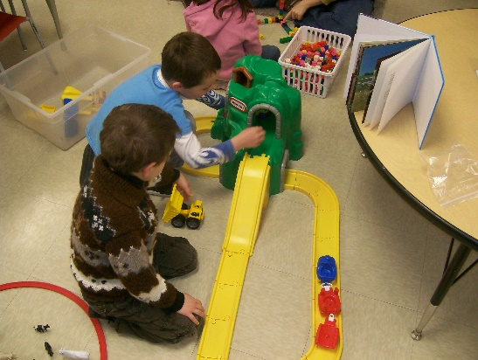

Program Reviews

These are conducted by:
- Alberta Education
- Early Learning & Child Care (Central Region CFSA)
- United Way of Central Alberta Outcome Review

Professional Memberships

The Association holds the following memberships:
- kcs Association - member of Alberta Independent School and College Association (AISCA)
- Chamber of Commerce
- Alberta Association for services to Children & Families(AASCF)
- Family Resource Canada
- National Association of Education for Young Children (NAEYC)

Acts and Governances

We are governed by the:
- Society Act
- School Act
- Family Support for Children with Disability Act
- Early Learning and Child Care Act
- Child, Youth & Family Enhancement Act
- Persons with Developmental Disabilities Community Governance Act
- Protection of Persons in Care Act
- Freedom of Information and Personal Privacy Act
- Privacy of Personal Information Act
- Health Information Act

SECTION lll

GENERAL THINGS YOU NEED TO KNOW

CLASS DAYS AND HOURS

Toddler Daily (M,T,W,TH,F) 9:15 AM – 2:45 PM
Playschool Daily (M,T,W,TH,F) 9:00 AM – 2:30 PM
Junior Kindergarten (Pre-K) Daily (M,T,W,TH,F) 8:45 AM – 2:15 PM
Kindergarten Thurs, Fri, every 2nd Mon (see calendar) 8:45 AM – 2:45 PM
Outdoor Adventurers Tues and every 2nd Mon or Wed (see calendar)9:00 AM – 2:30 PM
Kids Kamp Tues through Friday 8:30 AM – 3:30 PM
July through August
Early Intervention Daily (M,T,W,TH,F) Same as Program Time
Extended Hours Program Days 8:00 AM to Child’s Program Time & end of Child’s Program Time to 4:30 PM
Afterschool School Days School dismissal until 5:45 PM *Afterschool is not operating at kcs for the 2021/2022 school year.

YEARLY SCHEDULE

Classes begin the week of September 7 and end the week of June 17 (Kindergarten June 24). The monthly newsletter will include information on what is happening in your child’s class, what the interest is and holiday closures. Please see attached yearly schedule.

ARRIVALS AND DEPARTURES
We ask that you please
- park at your designated area given to you by your child’s educator
- be sure that your child is dropped off and picked up promptly at set arrival and dismissal times
- contact the school if someone other than the usual or designated person will be picking up your child
- notify the office of any absence or illness
- complete the necessary pre-screening checklist each day your child attends

These procedures are in place to ensure the health, safety and supervision of your child as well as to assist with the operation of our programs.

Please note that this year, parents will be met at the appropriate outside door by an educator for arrivals and dismissals. There will be no parents permitted in the center. If you need to enter the center, please make an appointment with the main office. Safety protocols will be necessary, pre-screening, masking, and sanitizing.

It is also necessary to provide an emergency contact, other than a parent, who will be available to pick-up your child in less than 30 minutes if needed.

If a child is pick-up late, a late charge will be applied to your account.

RECORDS

All administrative records are maintained and stored in the main office, including Children’s Records. All portable records for exiting the site for any reason are kept in the individual classrooms.

UNAUTHORIZED PERSONS POLICY

An ‘Unauthorized Person’ is anyone who is not clearly stated on the registration form and/or any person who is incapable (intoxicated, medicated, etc.) of caring for your child. It is important for kcs Association staff to know who is authorized to pick up your child thus the ‘alternative pick-up’ person listed on the registration form must be kept up-to-date. If an unauthorized person arrives to pick up your child, access will be denied. Your child will remain under the supervision of kcs Association Team until an authorized person arrives for pick up. Authorized persons are required to show photo identification.

Note: Biological parents cannot be designated as unauthorized persons without clearly stated legal documentation on file. These individuals can be deemed as ‘unauthorized’ by kcs Association staff if they are incapable (intoxicated, medicated, etc.) of caring for your child.

SUBSIDY

Subsidies are available to offset the cost of child care for eligible lower-income families. Find more information and how to apply here: Child care subsidy | Alberta.ca

STRATEGIES FOR GUIDING BEHAVIOUR

At kcs Association, we understand the nature of young children’s tremendous level of curiosity and the need to test and explore things. The role of the Early Learning Team is a supportive one in assisting the child developing their sense of self in connection with others. We follow an active approach of observing and modifying the environment, as needed, so that children can be successful.

Interventions are made when a child requires extra support work. Interventions include: redirecting play activity, separating the child from the problem, pre-planning, modeling, and role-playing appropriate behavior. The team works with parents to develop strategies and provide help as needed.

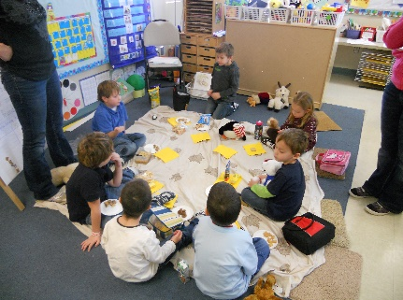

DISCIPLINE POLICY

kcs Association defines discipline as, “training or instruction used to help a child understand expectations for positive social interactions and to learn self-control by reinforcing safe and socially acceptable behaviors.” The Team may use redirection, modeling, verbal and/or visual cues, giving time away from the group and/or activity or assist the child with specific choices, as is reasonable for the circumstances. Centre staff do not deny or threaten to deny any necessity. Any act of physical or verbal degradation or emotional deprivation is not allowed. Corporal punishment-(spanking), physical restraint, isolation or confinement-is not permitted at our Centre. Child guidance/discipline plans for children, whose ability to understand and learn self-control is impaired because of a developmental delay or disability, shall be developed based on the child’s individual needs.

If a child requires behavioral support while at the Centre, he/she is assisted in taking some time away from the situation to allow time to calm down. The amount of time away will depend on the child. A Team member then speaks with the child explaining why such behavior is not acceptable. The child will be allowed to return to the group or activity after indicating to the Team member that he/she is ready. The Team will monitor and support time away.

PROVISION OF SNACK and LUNCH

kcs Association will provide a snack-time twice during the day and one scheduled lunch-time. Snack and lunch items are the responsibility of the parent(s). kcs does keep extra snack items on hand to be issued if necessary. A Team member will inform parents if additional snacks are needed for a child and/or if alternative snacks are required due to allergies in the class. If a child does have a special diet due to health concerns, extra snack items supplied by the parent can be kept in the class to be used as needed.

Safety is a priority. To reduce the risk of choking, small, hard, or round foods are not allowed as they can block a child’s airway. Please grate or finely chop hard vegetables and fruits. Remove pits from fruit and cut grapes into quarters. Wieners must be cut into length wise spears. No beverages are provided to children while napping to avoid choking. Please Note that kcs Association is a nut safe zone, no foods containing nuts are permitted on site.

Peanut/Nut Safe Policy and Allergy Guidelines

We are a peanut/nut safe-zone. This means that no peanuts/nuts or products that say may contain are allowed in our Centre. This is for the protection of children who experience life threatening reactions. This can occur when peanut/nut residue on somebody’s hands contacts a surface that the allergic person then touches. Classroom allergy information will be shared with the class parents. You may be given a list of foods that cannot enter the Centre and a list of the substitutes that may be brought instead. Please provide healthy choices.

CLOTHING

Please make sure that your child comes to school dressed in clothes that are for play. This means clothing that is easy for your child to put on and take off. Velcro shoes or slip on runners and elastic waist pants are recommended for toddlers and play schoolers.

It is important to:
- have a complete change of clothes appropriate for the weather
- label all items to help staff keep track of clothing
- keep a pair of indoor footwear at the Centre
- send belongings in a clearly marked bag or backpack

SCHOOL CLOSURE

The Centre will be closed on the following holiday periods:

- Labour Day (September)
- Thanksgiving Day (October)
- Remembrance Day (November)
- Christmas Break (2weeks) (Dec./Jan)
- Family Day (February)
- Spring Break/Easter (1week) (March/April)
- Victoria Day (May)
- Canada Day (July)
- Heritage Day (August)

Professional Development Days

There will be no classes on designated professional development days. These days are scheduled for the year and indicated on the calendar given to all parents at the beginning of the year. (attached)

Weather Policy

Severe weather closure takes effect when driving is restricted/not permitted. We do not close based on temperature, however outdoor activites will be restricted due to inclement weather. The decision to close will be made 2 hours prior to the beginning of the program and communicated through “Remind”. Please ensure that you join remind according to the instructions given by your child’s educator to ensure you have receive important messages. You can also call the main phone number, (403)887-5330 and the message will inform you of a closure.

EMERGENCY EVACUATION PLAN

In case of emergency, children at the Centre will:

- exit out of the Centre through the main north doors led by the Team member in charge, carrying portable emergency records, first aid kits and any needed medications
- ensure that all children are evacuated by having a Team member check the washrooms, closets, and play areas
- key Team member will notify the fire department or other emergency personnel
- assemble on the sidewalk along the west side of the C.P. Blakely playground and near the mailboxes outside the Community Center on 43rd Street
- conduct a roll call to make sure all the children are accounted for
- proceed to the Alliance Church if necessary
- parents will be notified to pick up their children as soon as possible

This procedure is posted on the loop doors along with contact information.

It is the policy of the Centre to practice a fire drill once a month. We will continue to do this with the classes having separate times/exit doors. To help deal with emergency situations, kcs posts emergency contact lists by each of the phones in the Centre.

NOTIFICATION OF TERMINATION/WITHDRAWAL

Parents are required to give one month’s notice to the main office in advance of termination or to give one month’s fees in lieu of notice.

SUSPENSION/DISMISSAL

We will work to pursue all possible avenues to prevent suspension or dismissal from the program. Should a child’s behavior endanger the safety of the child or others and if the child’s parents/guardians refuse supports to assist the child in dealing with these behaviors, then the following procedures apply:

- concerns regarding a child will be brought to the attention of the parents/guardian
- every attempt will be made to resolve the problems by the Early Learning Team, the Program Director and the Principal/Executive Director
- if a resolution is not possible, the Principal/Executive Director reserves the right to dismiss the child from our Programs
- written notification of such dismissal will be given to the parents/guardians. Parents may appeal this decision to the Board of Directors.

PARENT/EARLY LEARING TEAM COMMUNICATION

In maintaining a child-based and family-focused Centre, we are here to work in partnership with you. We are available by phone or in person to discuss any concerns. We are happy to have informal meetings at the parent’s request. Appointments are necessary or we can set-up phone or video conference meetings. In Kindergarten, report cards are given two times per year: the middle and end of the year. Other programs do not issue report cards.

For general information, educators use a system called “Remind”. Parents can download the APP called Remind and receive bulletins from the educator to keep them informed of interests, changes, schedules, etc. Parents can also get information on our Facebook page and through newsletters. Educators will make every attempt to include parents by sending photos, etc. as the limitations of the pandemic apply. As well, if you have a question, you can always call us or email us.

In order to help us provide the best possible education and care, we ask that you:
- call us if your child will be absent with the reason for their absence
- let us know of any illness/symptoms, or communicable disease
- keep your child at home if your child, due to illness, is unable to participate in the full day’s routine including outdoor play
- inform us right away of any changes to work, home or cell phone numbers so that you can be reached at all times
- let us know immediately of any concerns, problems or ideas
- observe the smoke free environment

Section IV

PROGRAMS FOR CHILDREN

We strive to be sensitive to and to include a variety of cultures, families, individuals and abilities. We strive to teach children to respect differences as well as to value their own unique qualities. We want to assist children to function successfully in a multicultural and multi-dimensional society.

MODEL FOR LEARNING

CHILD-CENTRED FOCUS AND LEARNING THROUGH PLAY

A developmental and child-centered focus is maintained by all programs with emphasis on each of the areas of SPICE - Social, Physical, Intellectual, Creative and Emotional development when considering the needs of each child. These goals are adapted to meet the needs of each developmental age group as well as the needs of individual learners.

To meet the development goals of SPICE, kcs Association programs provide opportunities so that children will develop the following areas.

Socially
- Develop personal responsibility and independence
- Learn to express feelings in socially acceptable ways
- Practice meaningful communications
Physically
- Gain confidence in small and large motor activities
- Use and experiment with equipment and materials
- Develop understanding of their bodies in relation to space
Intellectually
- Gain problem-solving skills
- Understand similarities and differences in people and environment
- Develop the ability to work independently and with others
Creatively
- Explore a variety of media in language, music and the arts
Emotionally
- Develop a secure sense of self in relation to others
- Explore feelings and expression of feelings

FLIGHT CURRICULUM

Flight is a new curriculum framework in Alberta that is an important tool to guiding the important work of early learning and child care educators with young children, and their families. Children’s play is the central focus to this curriculum framework, and for thinking about how children learn and experience their worlds.

EDUCATOR AS PLAY PARTNER

The Educator’s role is to participate in the child’s learning by:
- using open-ended questions to facilitate language and understanding
- providing structure through daily routines, projects, and by setting learning PLAY objectives
- ongoing evaluation and adaptation of curriculum
- allowing for an active learning environment
- playing with children and encouraging exploration

RESOURCE TEAM

Our combined Team of educators and specialists are equipped to identify learning strengths and challenges. Individual programs are developed and coordinated with the classroom Team.

FIELD TRIPS

Parents will be notified about upcoming field trips through class newsletters/calendars. Currently, we are restricted and cannot plan field trips until pandemic conditions change.

PROGRAMS

TODDLER

The Toddler program is for children ages 21 months to 39 months with a maximum of 12 children per class. The program runs daily, Monday through Friday from 9:15 to 2:45.

Activities Provided

The Toddler program provides a supportive early education and intervention environment. It aims to support the development of:

- sensory - motor abilities
- gross and fine motor coordination
- communication
- social and self-help skills

Toddlers will be able to experience various art and craft activities. They also participate in various cultural activities such as singing songs, doing action songs, dances, and stories. The children have free play time where they can explore in various centers and experience learning through play and develop socialization skills.

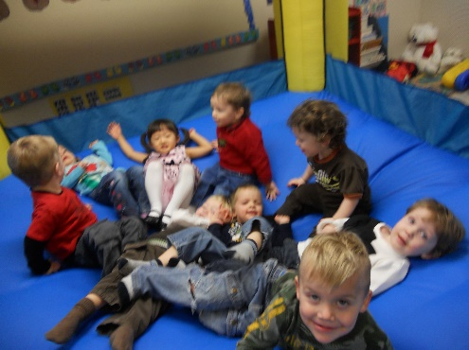

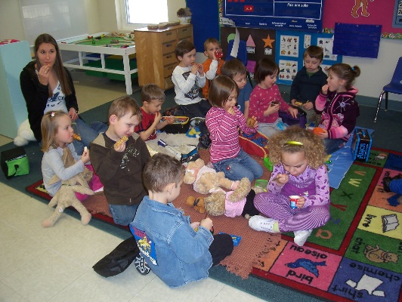

PLAYSCHOOL

The Playschool program is for children who are 3 to 5 years of age with a maximum of 16 children per class. Classes are offered daily, Monday through Friday from 9 am to 2:30 pm.

The Playschool, through a play-based learning approach, offers opportunities for children to develop their:

- social skills by interacting with peers and caring adults
- sense of pride in their own individuality
- communication abilities
- creativity through various arts and crafts
- knowledge of music
- motor skills through fine motor & visual motor activities, gross motor activities and outside play to address sensory needs to enhance learning maximization

Feel free to talk to your child’s educators regarding your child’s program and progress.

JUNIOR KINDERGARTEN & PRE-KINDERGARTEN

kcs Association offers a combined Jr. Kindergarten and Pre-Kindergarten. Children, who are 4 years old (as of December 31st) will learn together in an enriched, integrated setting. The program runs daily from 8:45 am to 2:15 pm.

In preparation for Kindergarten, the program focuses on a number of key skill areas.

- reading readiness via visual and auditory discrimination activities
- math readiness with counting, graphing and patterning skills
- arts and crafts - exploration of a variety of media
- music and drama experiences

Specialized supports including speech, occupational and physical therapy are available through the Early Intervention team.

OUTDOOR ADVENTURES

This program provides opportunities for children to learn within the scope of nature and uses the grand outdoors as a classroom. Much like the other programs, children participate in center play, literacy activities, crafts, music and interest-based activities The program is open to all children ages 3 to 6 years old. Class size is limited to 12 children.

Outdoor Adventures is offered on Tuesday and alternating Monday’s or on Wednesdays. The class runs from 9 am until 2:30 pm. Children are required to bring indoor shoes, snacks, lunch, a water bottle and appropriate outdoor clothing. The educator will provide a list of required supplies in September.

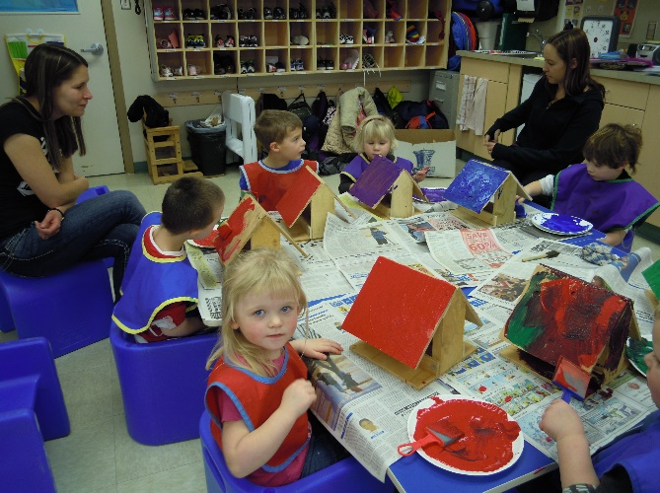

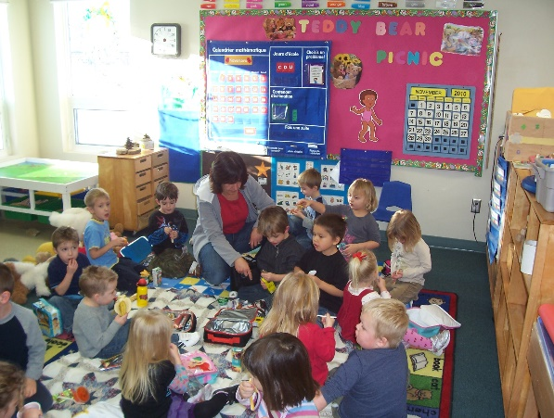

KINDERGARTEN

We are a member of AISCA (Association of Independent Schools and Colleges in Alberta) and we follow the Alberta Education curriculum.

According to the ‘Win Win Program’ (developed by Brent Galloway, Justin Rindal, & Bev Friesen), the best learning is achieved if these 9 areas are met:

- Students learn better when class sizes are smaller. kcs Association caps the Kindergarten class at 15.
- Students learn better with an integrated and interactive curriculum based around the student needs and interests. At kcs Association, we use cooperative learning, role-playing, games, discovery learning, field trips, and centers. This makes the curriculum more interactive and hands on.
- Students learn best when they have the help they need. During center time, the student will get 1-1 help from the teacher. At kcs Association, we work very closely with the Early Intervention Team and the parents to access help when needed.
- Students learn best when they are empowered to be the best they can be. At kcs Association, the children take turns being the helper of the day. They are empowered with techniques to solve social conflicts.
- Students learn better when their learning styles are addressed. At kcs Association, every child is treated as an individual. Therefore,
every child deserves a program to meet their needs. All Kindergarten children are evaluated by the Early Intervention Team to help establish learning styles.
- Students learn best when there is recognition for positive behavior are there are fair and logical consequences for inappropriate behavior. At kcs Association, we emphasize children at their best. We work hard focusing on the things they are doing right and model
appropriate behavior.
- Students learn best when the physical space accommodates their needs. At kcs Association, the Kindergarten has centers and tables for group work. The centers meet a variety of needs such as fine motor, sensory needs, gross motor, creative and intellectual learning.
- Students learn best when there is a ‘team’ approach to teaching and learning. At kcs Association, we have an open-door policy for
parents. We work very closely with the classroom Early Interventionist and the Early Learning Program Director. Case conferences
are also offered to all special needs students.
- Students learn better with fewer transitions. At kcs Association, Kindergarten classes run Thursday, Friday and every 2nd Monday to assist children with establishing a daily routine typical of a school environment.

The program starts at 8:30 am and ends at 3:00 pm with a lunch break and 2 recesses similar to any school. Children bring their lunch and snacks and a water bottle. You will be provided with a list of supplies before school commences in September.

KIDS KAMP

Kids Kamp is a summer program that provides an enriched learning environment in which to enhance the skill development of children ages 3 to 6 years of age. This is an inclusive program and available to children up to age 7 with the early interventionist. Kamp runs Tuesday through Friday from 8:30 until 3:30. Each week is focused on a different interest. See the website for specific details.

Kamp provides:
- developmental and recreational experiences
- continuity for the pursuit of developmental goals in a fun and interactive environment with peers
- opportunities for children to express themselves creatively and improve on social, problem-solving and developmental skills throughout the summer.

Children need to bring lunch, snacks, running shoes, outdoor clothing sun-screen, hats and bug spray.

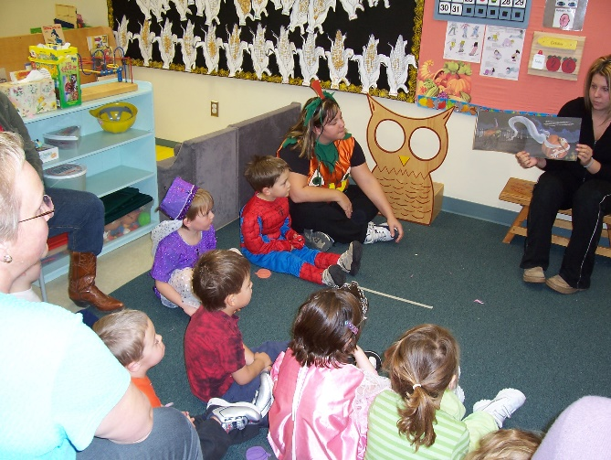

EARLY INTERVENTION PROGRAM

This program, in partnership with Alberta Education, serves children with exceptional learning needs. These include: gifted, mild to severe delays or difficulties including physical, mental, emotional, social or behavioral needs.

a). Classroom Component

The expectation for each preschool child is to extend play skills, interact with each other, and to increase responsibility and independence. This component is based on a small group approach in which most of the programming is presented through play - based activities. Each day provides opportunities to learn in small (2-3) or large (10 - 17) group activities. Learning experiences happen throughout the daily routine, for instance:
- Undressing at Arrival
- Free Play
- Songs, preschool skills, motor skills, language concepts, listening to stories
- Music Class - choosing partners, peer interaction, music concepts
- Bathroom Schedule - increasing independence
- Centre Time - structured opportunities to use language and develop social skills
- Gym or Outside time - to increase coordination, balance, movement, and cooperative play
- Dressing at Departure time

b) Therapy, Specialists and Adaptations

kcs Association works with various supports in meeting the needs of children.
These supports include:

- Speech-language pathologists
- Occupational therapy
- Physical therapy
- Child Psychologist
- Early Interventionist

Specific skills are worked on individually and within the group to promote optimum development. Adaptations are made for the specific needs of each child to build on his/her strengths and to integrate the child fully into the activities.

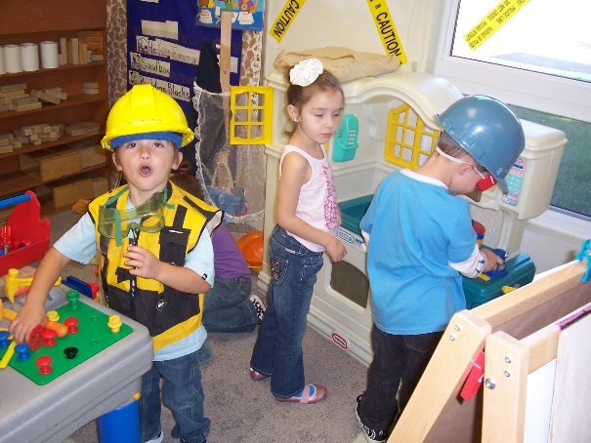

c) Case Conference

kcs Association holds case conferences, in addition to in class attendance. This is to assist the learning team to work together to determine a plan that identifies and fosters the pursuit of the child’s learning goals. Programming may be provided depending on the needs of the child.

Members of the learning team may include: parents, educators, speech-language pathologist, physical and occupational therapists, early interventionist, child psychologist, and the Program Director. Case conferences are held throughout the year, depending on the needs of the child.

The Early Interventionist will attempt to meet with the parents on a daily basis and/or through a communication book.
If it is the child’s last year in the program, the Director will provide information to the parents regarding schools being considered for the following year to help make a smooth transition to the next school year.

d) Individual Program Plan (IPP)

Each child with exceptional learning needs will have his/her own Individual Program Plan (IPP). The IPP is the plan of specific, measurable goals for each developmental area as determined by the child’s learning team. This plan is generally put together in the fall and regularly monitored for progress throughout the year.

e) Role of the Early Interventionist

It is the responsibility of the Early Interventionist to implement the child’s IPP in collaboration with the educators.. The Team works together to share ideas for program development, problem solving, developing specific strategies, evaluating progress, and reviewing goals.

Section V

EARLY LEARNING PROGRAM FEES

SOCIETY MEMBERSHIP

kcs Association is a non-profit Society incorporated under the Society’s Act. All families registered with kcs Association are considered members of our Society.

FEES & PAYMENT

Please see attached fee schedule on registration form.

- Non-refundable registration fee of $25.00
- Monthly fees must be paid within the first 5 business days at the beginning of each month.
- If fees are outstanding after the first 5 business days of the month, a notice of missed payment will be sent home stating the amount to be paid and the options for alternate arrangements going forward
- If no action is taken within two weeks of the notice, the child will be removed from their registered program.
- In the event of three (3) or more missed payments, the remaining balance for the years fees must be paid in full. Parents will have one month, from notification, to make this payment in full.
- Parents wishing to remove child from our programs are required to give 30 days notice or pay one month’s fees.
- Executive Director’s discretion will be used in exceptional circumstances.
- Preferred method of payment is Electronic Funds Transfer (EFT). We also accept e-transfers or cheques.

SUBSIDY

Our Early Learning Programs are eligible to accept subsidy.

Subsidy guidelines:
- If any portion of the monthly fees are not covered by Child Care Subsidy, it is the parent’s responsibility to pay this remaining portion. Parents will be billed monthly for these fees.
- It is the parent/guardian’s responsibility to keep all information current with Child Care Subsidy (i.e.: relationship status, work/school status, family income, reason for care, address, phone number etc.)
- If parent/guardian is eligible for subsidy they must provide kcs Association with copies of application and supporting documents. Monthly payment, or subsidy acceptance letter must be received by kcs Association prior to attendance.
- If parents wish to start their child before subsidy acceptance, monthly payments must be made. The parent will be reimbursed for fees paid when subsidy is received but will not be reimbursed for prior months paid before subsidy acceptance.
- If the parent/guardian becomes ineligible for any subsidy, they will be responsible for paying the full monthly fee.
- Renewal of subsidy must be started at the beginning of the month that the subsidy agreement expires, and copies of forms must be kept on file until acceptance letter is received.

kcs Association
PROGRAM FEES

1. Society Membership:
- kcs is a non-profit society. All families accessing kcs Programs are considered members of our society.

2. Program Fees:
    - Toddler Program:
1 day per week | $115.00/month
2 days per week | $230.00/month etc.

    - Playschool:
1 day per week | $110.00/month

    - Jr. Kindergarten:
1 day per week | $110.00/month

    - Kindergarten:
Thursday, Friday & every 2nd. Monday | $99.00/year

    - Outdoor Adventures:
1 day per week | $110.00/month
Tuesday & every 2nd Monday | $160.00/month

Extended Hours

Extended hours can only be accessed when added to a regular program. Add the desired Extended hours fee to your program fee.

Program Morning & Afternoon | Times | Monthly Fee
1 day/week | 8 am – 9 am and 2:00 pm to 4:30 pm | $120
1 day and every 2nd Monday | 8 am – 9 am and 2:00 pm to 4:30 pm | $190
2 days/week | 8 am – 9 am and 2:00 pm to 4:30 pm | $250
3 days/week | 8 am – 9 am and 2:00 pm to 4:30 pm | $350
*Registration Fee is non-refundable
*Fees subject to change
*Payment methods: EFT preferred. E-transfer and cheques also accepted.

Section Vl

PARENTS AS PART OF OUR TEAM

You are an important part of your child’s educational Team. In order to provide the best quality programming for your child we encourage parent/guardian participation. You will receive information on classroom activities, field trips and fund-raising events in the newsletter and through emails and the Remind APP.. Your support is essential. Some restrictions due to the pandemic limit parent involvement at this time.

NEW: In the past, kcs Association has used mandatory fundraising fees to supplement program fees. However, parent participation in fundraising on a voluntary basis remained at a high level and mandatory fundraising has been discontinued this year. We ae confident parents will continue with their every-present commitment in supporting kcs and their child whether it is a requirement or not. Thank you for your efforts.

Again this year, we will participate in 3 major fundraisers, Cutie-Pies, Sausage and Perogies and a ticket draw for a major prize.

RESOURCES FOR EDUCATION

kcs Association strives to aid parents in attending conferences, workshops, and purchasing resource materials that assist in understanding and enhancing the development of their child. Our Centre has a rich supply of parenting resources and information. Please be sure to advise us of materials that we can add to our collection.
Facility

Located within the Sylvan Lake Community center, certain facilities are shared. The parking is provided in the East end of the center. Public washrooms are conveniently located in the community center and are easily accessible. We also have one washroom specifically for the use of the children (especially potty-training time) easily accessible from all classrooms.

The playground is also a community shared area.

Classroom Layout

The layout of all classrooms and childcare areas are conducive to effective supervision.

NEW: In addition, we have added an indoor safe playground that we call “kcs Fun Space”. It includes many typical playground activities such as a slide, and tetter-totter. We have also added a mini-trampoline, obstacle courses, plasma-cars and a rock-climbing wall so that your child can have opportunities for physical play during the day, a important component of learning.

OPEN DOOR POLICY

We believe that, together, we can make a difference. You understand your child best. In partnership with you, we can provide the best possible experience for your child.

With our open-door policy, you are welcome anytime. (virtually until the restrictions allow) We will work with you and your child to deal with separation in order to foster your child’s greater independence, so please talk with your child’s educators about your needs.

* Please Note: In order to visit your child’s class or to volunteer at the Centre, all parents/family members are required to submit a Criminal Record Check that has been done before volunteering

kcs Parents Committee

If you have additional time to volunteer outside your child’s classroom, we would welcome your participation. There will be more information available on the various committees and opportunities as the current restrictions subside. However, fundraising opportunities will be available throughout the year on a COVID-friendly basis.

We value your talents and interests and invite you to join in whatever areas you can.

Section Vll
HEALTH AND SAFETY

PARENT GUIDE TO ILLNESS
The following chart is given as a guide to common early childhood diseases and illnesses that may be encountered in a group setting. Your child's physician or local community health services can provide you with more detailed information. Routine early childhood immunizations and good hand-washing practices prevent many of these illnesses.

Information summarized from Alberta Health Services Guide to Communicable Diseases.
Illness Name and Signs | Time from exposure to onset | Infectious period when spread
Chicken Pox  Low grade fever, achy and fussy, rash | 2-3 weeks | 1-2 days before to 5 days after onset of the rash
Pink Eye (conjunctivitis)  White part of eye looks red, may have pus and feel itchy | 24-72 hours | Until antibiotics have been taken for 24 hours
Fifth Disease  Very red rash that starts on cheeks and spreads to arms and rest of body, may have low grade fever | 4-20 days | Greatest up to 2 weeks before rash appears, not infectious after appears
Hand, Foot and Mouth Disease  Fever, ulcers in mouth and blisters on hands, feet and buttocks | 3-5 days | For the length of the illness, about 7-10 days
Impetigo  Rash especially face, around mouth and nose, and arms and legs | 1-3 days | From the time sores appear until 24 hours after starting antibiotic treatment
German Measles  Fine, raised pink rash, appears on face, neck and spreads to trunk, swollen glands and achy joints | 14-21 days | 7 days before rash appears (up to ½ infections occur without rash) and at least 4 days after
Measles  Moderate to high fever, red runny eyes, nose and cough, child appears very ill, dusky red blotchy rash that begins on face and spreads to body | 6-21 days after being in contact with someone who has the measles | From 1-2 days before feeling sick until 4 days after rash appears
Baby Measles  Sudden onset of fever, fever disappears, and rash appears, rash that starts on trunk and spreads | 10 days | Unknown
Mumps  Fever, swollen glands, difficulty swallowing | 15-18 days | 6-7 days prior to swelling and up to 9 days after swelling appears
Whooping Cough (Pertussis)  Begins with runny nose and cough, cough is often worse at night, can cause shortness of breath | 7-20 days | From onset of cough until your child has had 5 full days of erythromycin or 3 weeks from start of coughing or until coughing stops
Scabies  Intense itching, especially at night, tiny blisters on elbows, hands, wrists, arm pits; small raised areas then wavy, grey-white burrows | 2-6 weeks in persons with no previous exposure  1-4 days after re-exposure | Until mites and eggs destroyed by treatment
Scarlet Fever  Fever with sore throat and headache, may have red, swollen lips, fine pinkish red, raised, rough rash | 1-3 days | Until 24 hours after antibiotics completed; up to 2-3 weeks if not treated

ILLNESS AND PROGRAM ATTENDANCE

A child with the following symptoms will not be allowed to participate in kcs Association Programming. If the symptoms develop while the child is ‘In-Centre’ parents will be required to immediately remove the child: | A child may return to kcs Association programming when:
The child has a fever of 38.0 C (100.4 F) | The child’s fever has remained below 38.0 C for 48 hours without medication
The child is vomiting or has diarrhea | The child has been symptom free for 48 hours
The child has a new unexplained rash or cough, sore infected eyes, or signs of any contagious disease | The child has been examined by a doctor and has received written medical clearance
The child has any bacteria/parasite related condition | The child has been examined by a doctor and has received written medical clearance

ACCIDENT AND ILLNESS PROCEDURES

In the event of injury, the procedure will be as follows:
- a qualified Team member will administer first aid, if required
- the parent, or if parent is unavailable, emergency contact person will be contacted immediately
- an ambulance will be contacted, if required
- the child may be transported to one of the medical clinics in Sylvan Lake or to the emergency ward of Red Deer Regional Hospital, depending on the severity of the injury

In the event that a child falls ill while in the care of kcs Association, the procedure will be as follows:
- the child will be comforted by a Team member on her/his mat with a blanket in an area where he/she can be isolated from the other children, if required, and still be observed by a Team member
- parents will be contacted immediately and if unavailable then the emergency contact will be notified
- the child will be kept comfortable in the isolated area until the contacted person arrives
- an ambulance will be called, if required
- the child will be transported to a local medical clinic or Red Deer Regional hospital if needed

In the case of a disagreement between a parent and staff member whether or not a child is ill, the Principal/Executive Director (or designate) shall make the final decision. It is the parent’s responsibility to make alternative arrangements for their child.

A child can return to the program if the child’s parent provides written notice from a physician indicating that the child does not pose a health risk or if kcs is satisfied that a child no longer poses a health risk to other children, caregivers, or staff (for example, the child has been symptom free for 48 hours).

kcs Association tracks all incidents, accidents, and illness on special forms in order to monitor trends, review areas of needed staff in-service, etc. These reports are reviewed by the Team member, the supervisor, the parent and the Principal/Executive Director. kcs Association is under government regulation to report incidents of a serious nature or illness trends to Regional CFSA and/or Health authorities.

Of course, the current AHS regulations are in place and strictly observed. We are required to follow the most restrictive rule whether it is AHS or Early Learning and Child Care Act.

ADMINISTERING MEDICATION

kcs Association Team will only administer medication to a child under the following conditions being met:
- a physician prescribed the medication
- the child’s name is on the prescription
- the prescription is given to the Centre by the parents or by authorized medical personnel
- the prescription is current

- the prescribed medication is in its original container
- only the dosage and time on the label will be administered
- a kcs consent form, signed by the parent is received
A record will be kept of the name, dose and time of all medications administered by a Team member as well as the name of the Team member administering the medication. Prescribed procedure will be followed to support asthmatic children with daily contact with the parents with regard to the child’s condition and with record checks and reviews to support changes. Medication will be tagged and put in the locked cabinet except for emergency medication (epi pens and asthmatic medication) which will be kept up high in the individual child’s backpack in a designated place out of reach of the children.

SAFETY

Providing safety is a priority. We want to take a moment to assure you that we have many ways to look after the safety of your child. We have the following practices in place:
- Children will only be released to an authorized adult
- kcs Early Learning Team is trained in CPR and First Aid. This training is updated regularly.
- We are inspected for fire safety and fire drills are held regularly.
- All toys and equipment are selected with safety in mind and are checked daily and maintenance done as necessary,
- kcs Early Learning Team members are required to have a Criminal Records Check and Vulnerable Sector Check completed before they begin employment at the Centre. Both checks are renewed every 3 years.
- Volunteers are required to have a Criminal Records Check completed before volunteering.
- Children remain in their cohort to limit exposure.
- All materials remain with the cohort.
- Everything is cleaned and sanitized daily.

PEANUT SAFE/ALLERGY GUIDELINES

We are a peanut/nut safe-zone. This means that we strive to keep our environment safe from foods containing peanuts/nuts or that say ‘may contain nut products’. This is for the protection of children who experience life threatening reactions. This can occur when peanut/nut residue on somebody’s hands contacts a surface that the allergic person then touches.

Allergies are posted so that snacks that come into a classroom can be carefully chosen and monitored. You may be given a list of alternative snacks that may be brought into the classroom to replace foods/food products that produce allergic reactions in children.

SMOKE FREE

kcs Association is a smoke-free environment. Smoking of any type is not permitted near the facility and all posted requirements are observed.

SUN SAFETY

In order to protect your child from the intense rays of the sun, please be sure to send the following to the Centre with your child:
- sun hat
- sun screen
- sun glasses (are recommended)
- we do not administer sun screen that does not belong to your child

REPORTING ABUSE

Everyone who has a reason to believe that a child has been or is likely to be physically, sexually, emotionally abused and /or neglected is legally responsible to report the matter to Regional Child & Family Social Services Authority. Therefore, if kcs Association staff have reason to believe that a child is being or is likely to be abused and/or neglected; we are obligated to report to the appropriate authorities.

